.

Name:

|  |  |
| --- | --- |
|  | Pivot Table |
|  | Subtotal |
|  | Table Construct |

R

|  |  |  |  |  |
| --- | --- | --- | --- | --- |
| Q1 | Q2 | Q3 | Q4 | Total |
|  |  |  |  |  |



1

15pts. Please look at the file: **prostate cancer study.docx.** This is a medical study of patients with prostate cancer. If you read this, you will see that patients were given a choice of treatment. Bring the word table at the bottom of the document into an excel spreadsheet.

Now, with this sheet, let’s create a pivot table to determine the average prognosis of the patients in each trial and at what stage their cancer is at the time of treatment. This will be a two dimensional pivot table.

Create a pivot table using treatment for row, stage (cancer stage) for column and for values, use the average of the efficacy. (You will have to set average). Round the values to 2 decimal places.

Finally, Use an appropriate format for your pivot table.

Save this file under a unique name. Email instructions are at the bottom of the test.

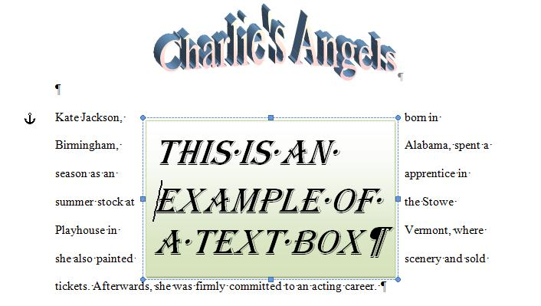

2

25pts. In the previous version of Excel, it was difficult to run multiple pivot tables using the same sheet for the underlying data. In this problem, we’ll show you that it isn’t that difficult. Access the 777rauer.stats.xlsx file and do the following.

1. Create a pivot table which displays for the months shown the number of hits that occurred.
2. Sort this pivot table by largest to smallest number of hits.
3. Pivot tables provide data which cannot be changed. But, it can be accessed as any other cell. Going downward, determine the increasing percentage per month for April and March of hits. Here’s an example although there are other ways: if Apr was 5000 and Mar was 4000, percentage increase would be 100*(5000/4000-1)
4. Run a pivot chart on the pivot table and format the pivot table to your taste.
5. Now, let’s go back to the underlying data in sheet1. Let’s run another pivot table indicating the unique hostnames that have accessed this web site and the number of visits for each. Set to 2 decimal points.

[](http://en.wikipedia.org/wiki/File:Caspar_David_Friedrich_006.jpg)Save this file under a unique name. Email instructions are at the bottom of the test.

3

30pts. As you may be aware, part-time instruction at CCP is very lucrative and with this money your instructor has been able to acquire quite an art collection, listed below, which you must type in as an excel spreadsheet. We’ll do this problem with the new table construct.

|  |  |  |
| --- | --- | --- |
| Artist | Name Of work | Appraised Value |
| Pablo Picasso | Menu Of Els Quatre Gats | 811000 |
| Johannes Vermeer | Woman Holding a Balance | 439000 |
| Rembrandt | The Raising of Lazarus | 1826000 |
| Munch | The Scream | 2475000 |
| Chagell | I and the Village | 1500000 |
| Eakins | Max Schmitt in a Single Scull | 560000 |
| Friedrich | Polar Sea | 325000 |

Insurance is not cheap and it’s made up of several parts which you’ll have to keep track of.

* Every object d’art (painting) has a $6000 policy fee for insurance. This is applied before any other cost.
* The coverage is rated at 6.5%. This means that a million dollar painting costs 65000 to insure.
* For those objet d’art above 1 and a half million (1500000) in value, a special assessment of 3000 is charged.

Total insurance cost for each painting is the sum of parts 1, 2 and 3. When setting up the new table construct, make provision for 3 new columns. The first column is policy fee, the second column is the insurance cost of 6.5% times the value of the artwork. The third column is the special assessment for art above a 1 million and a half in value and should be done by an IF statement. The final column is the sum of the first three columns. As an example, using The Scream, we have 6000+2475000*6.5%+3000=169875

1. Sort these pictures so that the highest insurance premiums (prices) appear first.
2. Determine the total insurance cost for my collection.
3. Determine the average insurance cost for each picture in my collection. Use the appropriate function and range.
4. Column headers should explain the columns.
5. Create a chart showing the painting title and the cost of insurance. What type of chart would you consider appropriate and why?_____________________________

Save this file under a unique name. Email instructions are at the bottom of the test.



4

35pts. In class we did a problem by subtotals. For this test, this problem will be done likewise, by subtotals. You are the excel spreadsheet expert for a realty company that owns a new High-rise rental building. They need some analysis. Open the file: community arms.xlsx.

In this you can see a spreadsheet indicating the floors and the units. The architect created layouts for 7 types of units designated as A through G. Rents are being charged as follows (and you are to put this into the spreadsheet).

A base fee of 500 per month is charged regardless of number of bedrooms.

For each bedroom, the additional charge is 300 per month for each bedroom.

An additional $100 a month is charged if you have a garage space (indicated as a 1 in 1=garage)

A yearly cost of 660 is charged if you have an upgrade package (indicated as a 1 in 1=upgrade)

A yearly charge of 900 is charged if you have joined the pool (indicated as a 1 in 1=pool)

A 5% added charge is given if you have a 1 year lease.

We need to know the monthly total rent for each unit. In the case of the upgrade package and the pool, this should be normalized to a monthly charge.

Now, let’s give an example of this. Assume a 3 bedroom unit, with upgrade, pool, garage and 1 year lease. The monthly rental would start at 500 + 300*3 + 660/12 + 900/12 + 100. This equals 1630 and the result of the added cost for a 1 year lease would be to increase this by 5% * 1630 (81.50) giving a result of 1711.50 for the month. If the lease was for more than 1 year, the monthly rental would remain at 1630.

A. Now, for each line item, let’s set the monthly rent. Set columns for

* The initial cost of $500
* The cost of the bedrooms (300 per bedroom)
* The cost of the garage space if they have agreed to pay for one.
* The upgrade package per month if they have agreed to it.
* The pool on a monthly basis if they have agreed to join it for this coming season.
* The net cost of the monthly rent which is the sum of what has been indicated above.
* The 1 year lease additional cost (5% of gross rent calculated above) if applicable
* The gross monthly rent which equals the gross monthly rent plus any discount.

B. We need column headers for these new columns that you have created and we would like to modify those headers already indicated to something like what’s indicated below. See if you can do both of these for your spreadsheet

|  |  |  |  |  |  |  |
| --- | --- | --- | --- | --- | --- | --- |
| Floor Number | Unit # | Bedrooms | Year Lease | 1=Upgrade Package | 1=Garage | 1=Pool |

C. It wouldn’t be a bad idea to force all the numerics into 2 decimal places as we showed in class.

D. Now, we would like to get an average monthly rental for each type of unit. You can see that an alphabetic designation is entered for each unit from A to G. Run a subtotal to accomplish this.

E. Sort the subtotal so that we can see the type of unit is reverse numerical order pertaining to the average monthly rent.

F. Create a bar (column) graph to show this visually.

Save this file under a unique name. Email instructions are at the bottom of the test.

**Instructions for mailing this (or using flash memory)**

It should be better from your standpoint to Email these answers to me. Your answers should be four uniquely named excel spreadsheets. Further, I want you to carbon copy yourself so that you hold what you sent to me just in case I need you to send it again.

*In the web Email setup of your choice, create a new Email message. The address to send this to is* [***777rauer@voicenet.com***](mailto:777rauer@voicenet.com)*. Carbon copy the web Email address you are using. The subject should be your name and your class schedule. Attach the 4 files that you have created during the test and mail it. I will try to keep my Email up to make sure it has been received.*

If using flash memory, there is no fail safe device as carbon copy. Nevertheless, I will bring in several memory sticks. You should Email me after the test reminding me that I put your problems on this,